How to disable lightshows

IOS
1. Get 'bellq' from Apps Store and install it on your iPhone
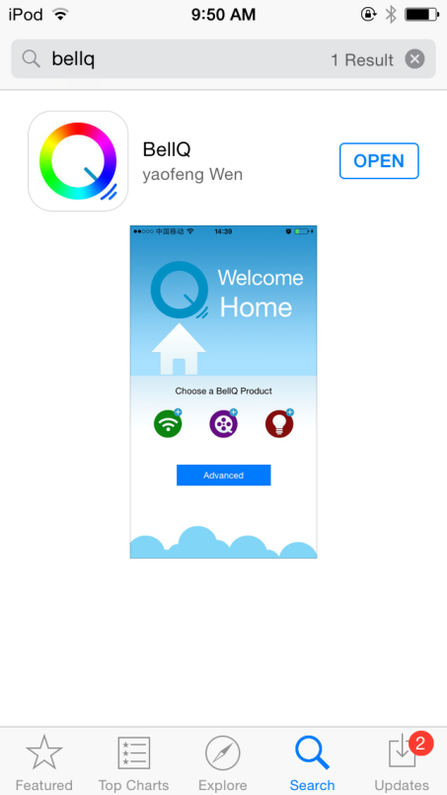

2. Run BellQ and click bulbs icon
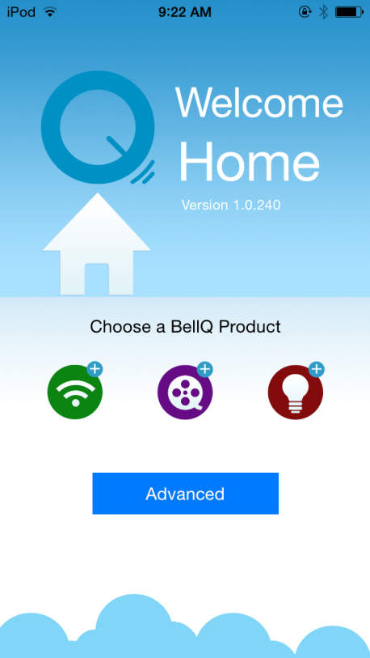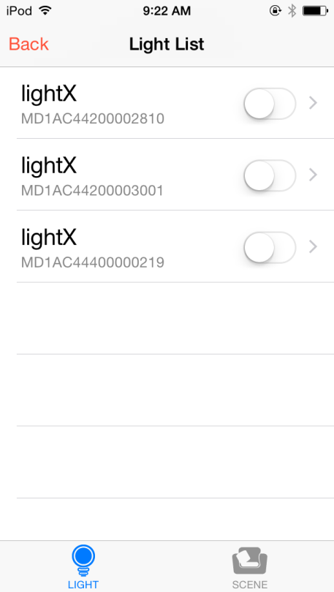

3. Click SCENE button at the bottom.
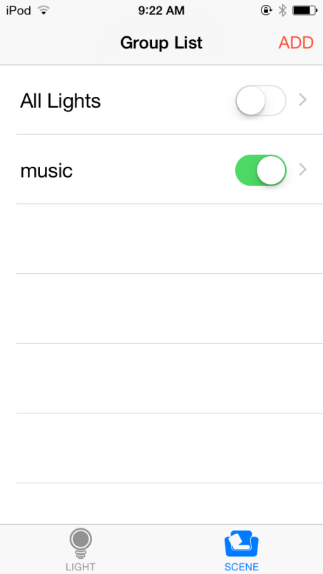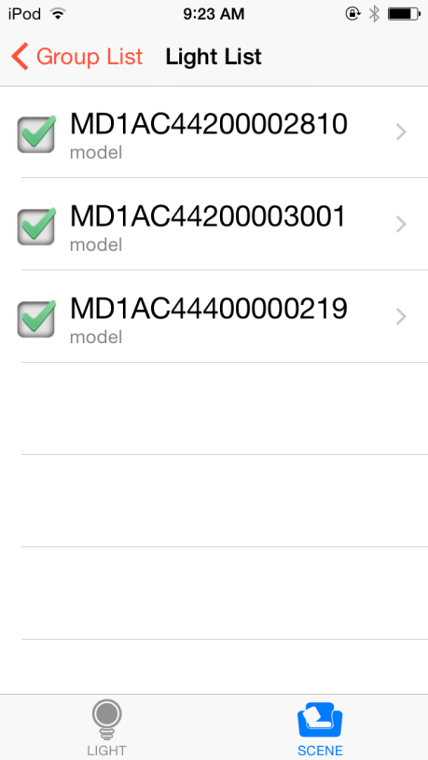

4. Uncheck all bulbs from Music group
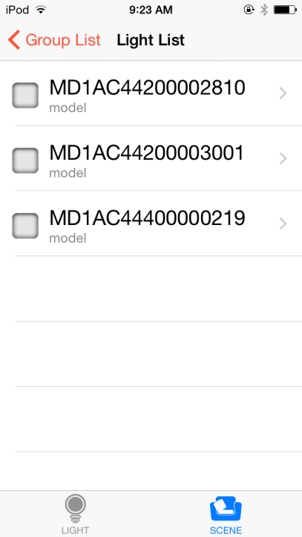

Android
1. Search 'Qlight' from Google Play and install it on your Android smart phone.
2. Run it and you'll see the page like below
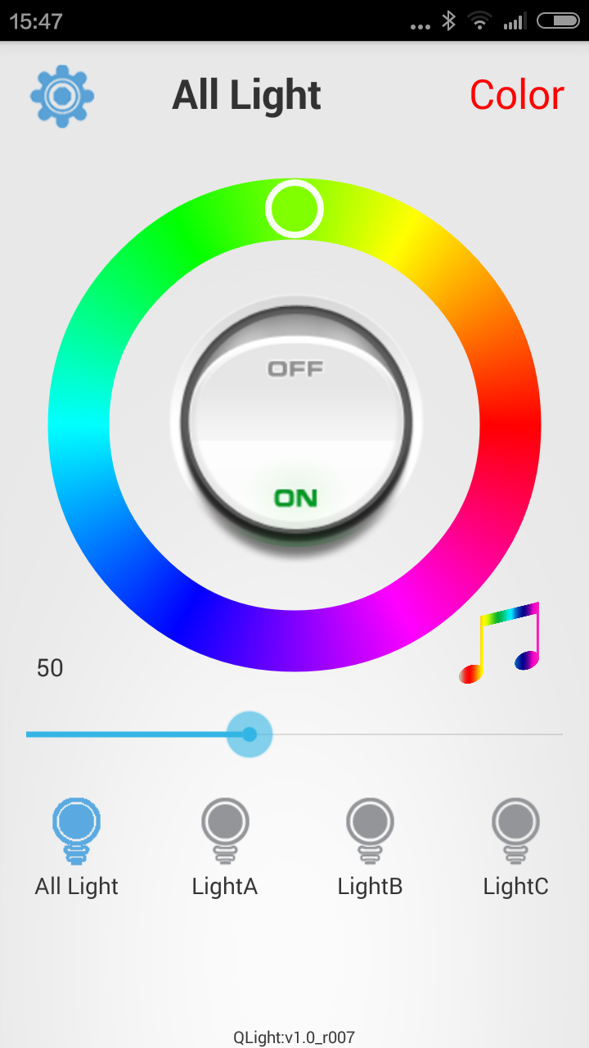
3. 1 click on music icon and then it will turn to grey color.
